**Course Project - Perform Analysis using SAS Procedures**

Shaun Pritchard

Rasmussen College

QMB4200

Terry Brookhouser

October 30, 2020

**Course Project - SAS Script using PROC GLM & PROC MIXED**

In this assignment I analyzed the route fare from LA to three different destinations and randomly assigned fare from five different websites to each Source destination pair. I use Prodigy LMFAO with the source data has the response in flight fare as the predictors and use proc mixed estimate the variance of the random effects and covariance is between the pairs of random effects in LMM.

This one I really had trouble with and would like to be shown how to do this correctly? I Unless my logic off, the independent variable would be the website (1,2,3,4,5). The route variable is string text so it can only be used for label or output. Route_A | Route_B | Route_C are the dependent variables. And this I cannot figure out for the life of me how to put these into SAS correctly to calculate the right calculations.

I tried several different variants of the method I had no trouble bringing in the data and calculating it with LMM. I assume I built my model correctly but now I'm unsure because the output of the data. Please advise

CODE:

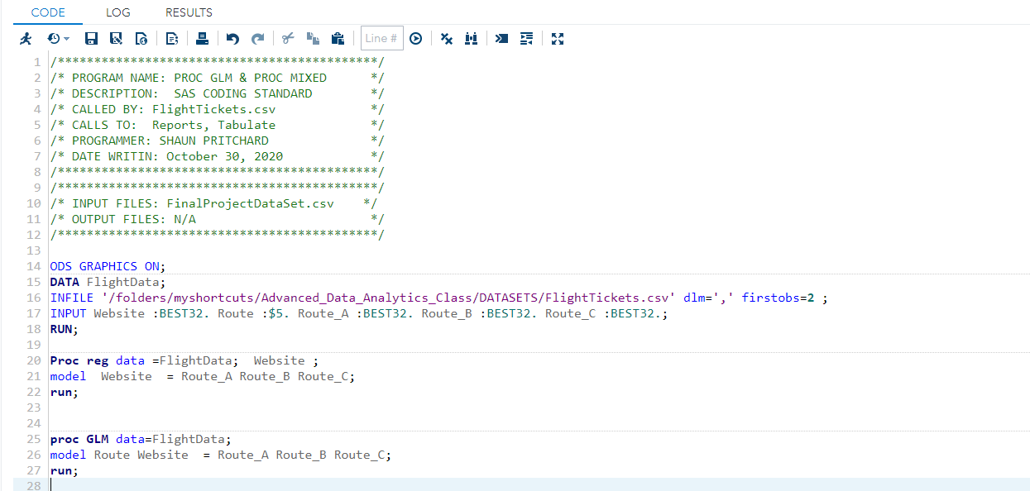

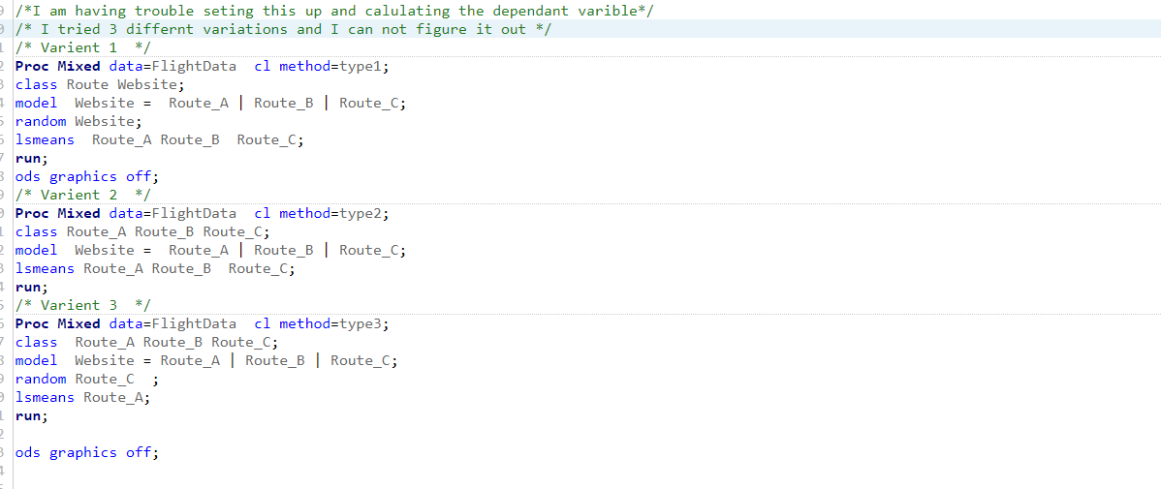

OUTPUT:

File Input:

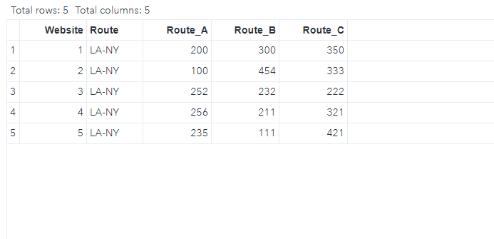

Reg DATA

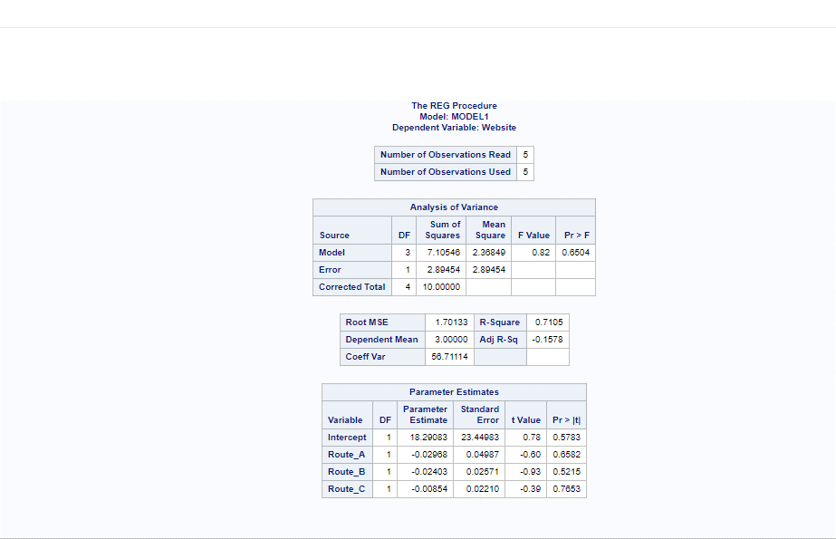

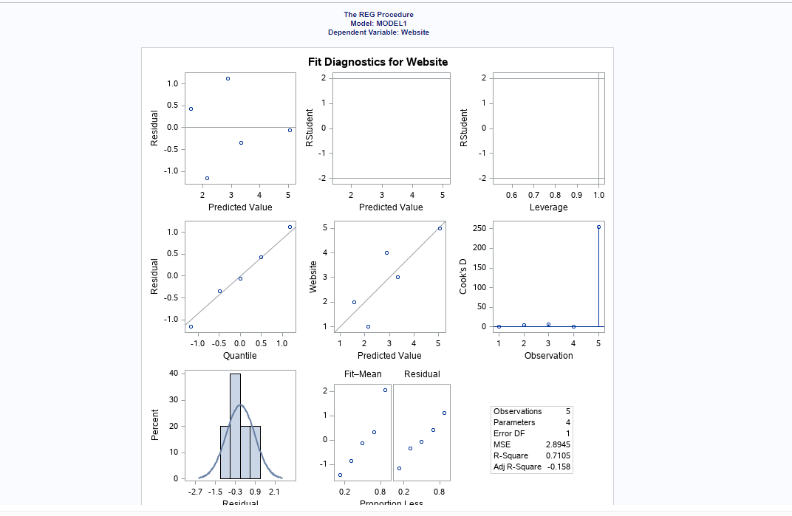

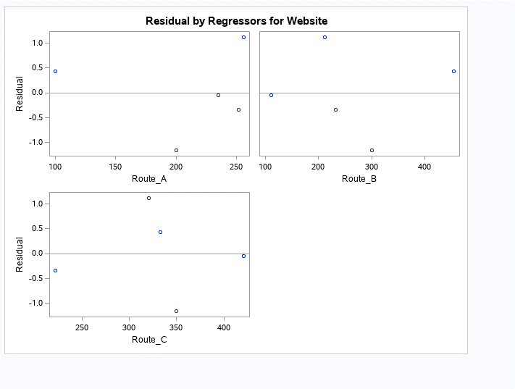

LMM:

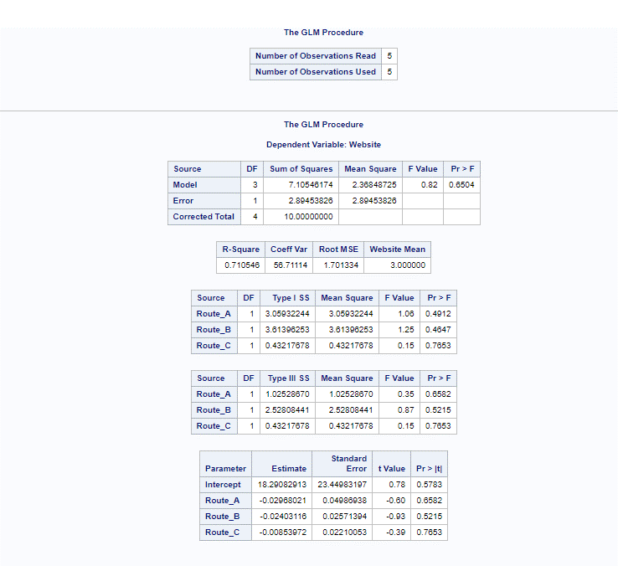

Mixed Procedure:

